HT12E Encoder IC
CP041
Image:
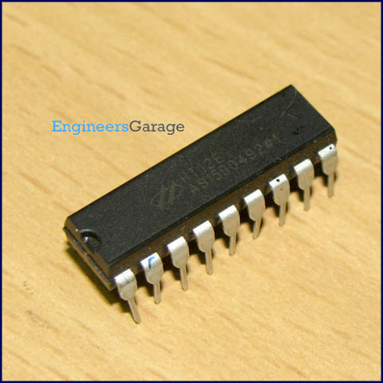
DataSheet:
HT12E.PDF
HT12E is an encoder integrated circuit of 2¹² series of encoders. They are paired with 2¹² series of decoders for use in remote control system applications. It is mainly used in interfacing RF and infrared circuits. The chosen pair of encoder/decoder should have same number of addresses and data format.

Simply put, HT12E converts the parallel inputs into serial output. It encodes the 12 bit parallel data into serial for transmission through an RF transmitter. These 12 bits are divided into 8 address bits and 4 data bits.

HT12E has a transmission enable pin which is active low. When a trigger signal is received on TE pin, the programmed addresses/data are transmitted together with the header bits via an RF or an infrared transmission medium. HT12E begins a 4-word transmission cycle upon receipt of a transmission enable. This cycle is repeated as long as TE is kept low. As soon as TE returns to high, the encoder output completes its final cycle and then stops.
Pin Diagram:
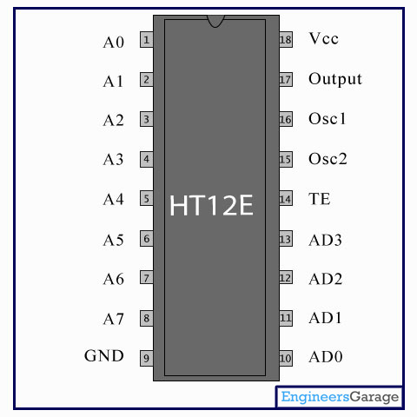
Pin Description:

Pin No | Function | Name
1 | 8 bit Address pins for input | A0
2 | 8 bit Address pins for input | A1
3 | 8 bit Address pins for input | A2
4 | 8 bit Address pins for input | A3
5 | 8 bit Address pins for input | A4
6 | 8 bit Address pins for input | A5
7 | 8 bit Address pins for input | A6
8 | 8 bit Address pins for input | A7
9 | Ground (0V) | Ground
10 | 4 bit Data/Address pins for input | AD0
11 | 4 bit Data/Address pins for input | AD1
12 | 4 bit Data/Address pins for input | AD2
13 | 4 bit Data/Address pins for input | AD3
14 | Transmission enable; active low | TE
15 | Oscillator input | Osc2
16 | Oscillator output | Osc1
17 | Serial data output | Output
18 | Supply voltage; 5V (2.4V-12V) | Vcc

